Full name: ______________________ Class: _________

WORKBOOK PAGE 20, 22

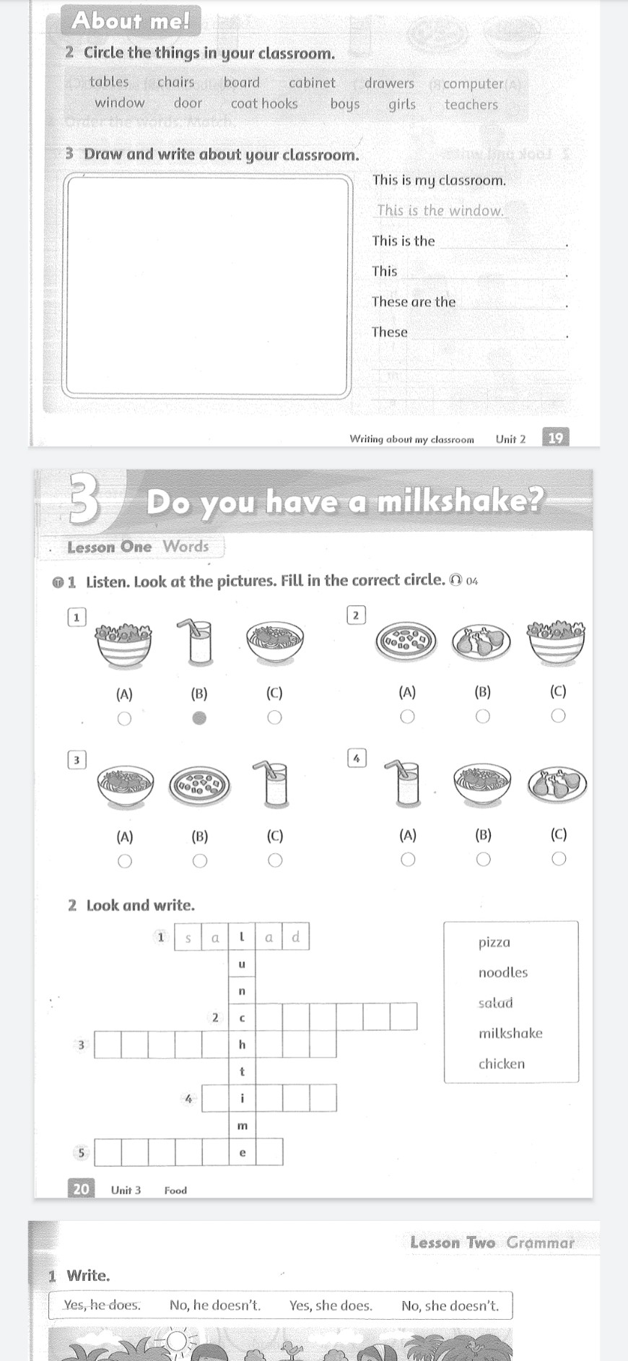

2. Look and write

1.Listen. Look at the pictures. Fill in the correct circle.

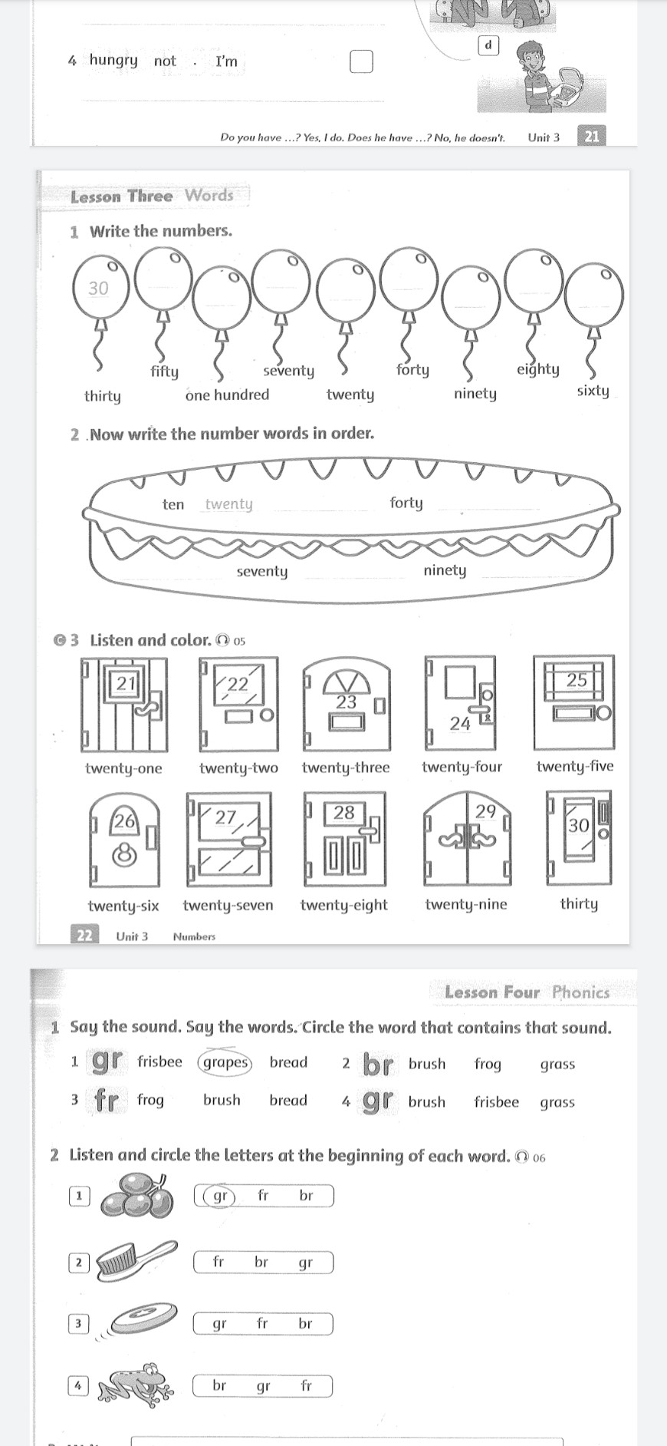

1.Write the numbers.

3. Listen and color.

2.Now write the munber words in order.